**Adding\Updating RM DB with TestShell Studio**

**Overview**

The purpose of this document is to describe how to populate TestShell Resource Manager DB by using TestShell Studio Client.

**CSV file preparation**

1. Create CSV file with the following column headers:
   1. Parent
   2. Name
   3. ResourceFamilyName
   4. ResourceModelName
   5. FolderFullPath
   6. Address
   7. Description
   8. Connected To
   9. [Attribute Name1]
   10. [Attribute Name2]
   11. [Attribute Name…N]

See Example:

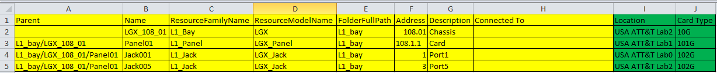

1. General assumptions:
   1. Yellow part is configuration section:
      1. The configuration section must be from A1 to H1 fields
      2. Column name should be exactly as defined above
      3. The order can be changed
      4. Don’t reduce\increase configuration section number of columns
      5. **Parent** - Should be empty for the Chassis level
      6. **Description** - may be empty
      7. **Name** - Can’t be EMPTY and must contain only alpha-numeric characters, space and the following characters .-| (dot, minus and pipe)
      8. **ResourceFamilyName** - Can’t be EMPTY, it must be the same as defined in RM
      9. **ResourceModelName** - Can’t be EMPTY, it must be the same as defined in RM
      10. **FolderFullPath** - If the folder doesn’t exist in RM DB, the test creates it
      11. **Address** - Can’t be EMPTY
      12. **Connected** **To** - According to the scenario, can be EMPTY
   2. Green part is attributes section:
      1. The number of attributes can be from 0 to N
      2. Make sure that the attributes defined in RM with “setting” tag
      3. Make sure that the attributes defined for the relevant resource model in Resource Manager->Admin->Resource Family

**Studio Test**

1. Copy “ResourceDistributionWithOptions.tstest” to “C:\Users\**[USER]**\Documents\TestShell Files\Tests\ResourceManager” folder (The test prepared for TestShell version 4.7.74)
2. Open Studio application (in online mode, login as TestShell administrator)
3. Open & Run ResourceDistributionWithOptions test
4. Set the full path for configuration CSV file and press OK button

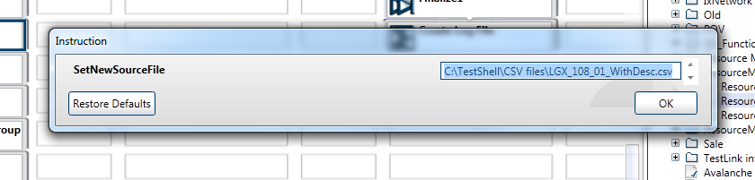

1. Set the following parameters and press OK :
   1. Start line
   2. End line
   3. Create Resource
   4. Create Route
   5. Set Attribute

